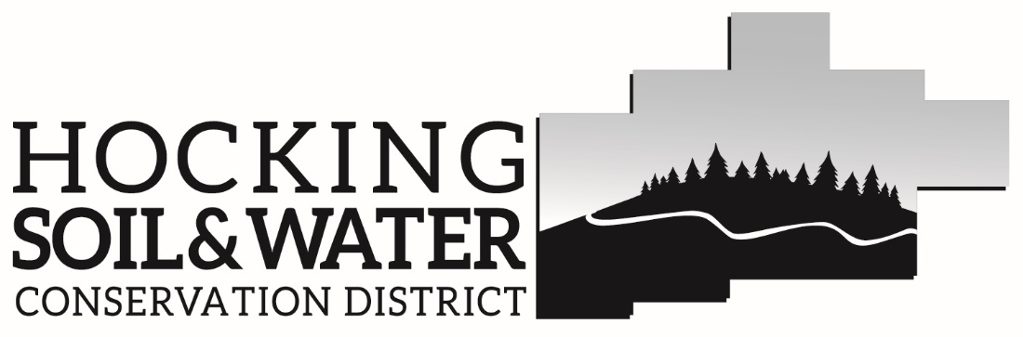
148 North Homer Avenue
Logan, Ohio 43138
740-385-3016

Liability Release

In consideration of my participation in programs sponsored by or in conjunction with the Hocking Soil & Water Conservation District,
I, ________________________, agree for myself, my child/ward, my heirs, executors, administrators or assigns to hold the Hocking Soil & Water Conservation District and any district employees, board members or their agents harmless from any and all liability, claims, demands, rights, or causes of action, payments or expenses of any nature whatsoever, by reason of person injury, property damage, or death sustained by me, while participation in the said programs, including but not limited to any office or field experience, or while as a passenger in any motor vehicle or other conveyance owned or operated by the Hocking Soil & Water Conservation District, its employees, board members, or their agents.

____________________________ _____________________________
Volunteer Signature Printed Name Date

____________________________
Parent/Guardian Signature
(Required if volunteer is a minor)

