**Suggested Plantings**

**SMALL TREES**- Mature height under 30’ (also good for within owner’s lawn)

* Minimum tree lawn (space from road to sidewalk) 3’ width
* Single trunk only

Serviceberry- *Amelanchier cxg* ‘Autumn Brilliance’, ‘Cumulus’, ‘Cole’s Select’

Thronless Cockspur Hawthorn- *Crataegus Crus-galli var inermis*

Ohio Pioneer Dotted Hawthorn (thornless)- *Crataegus punctata*

Winter King Hawthorn (thorned)- *Crataegus viridis* ‘Winter King’

Crabapples (many, but avoid over planting)- *Malus spp.* ‘Snowdrift’ (white flowers) and *Zumi calocarpa* (pink to white flowers) are two good ones

Tree Lilac- *Syringa reticulata* ‘Ivory Silk’, ‘Summer Snow’

Hedge Maple- *Acer campestre*

Paperbark Maple- *Acer griseum*

This is just a small sampling of acceptable trees. The Tree Commission can gladly review other requested tree plantings or make further suggestions to enhance the appearance of your property.

**Undesirable Street Trees**

The public tree lawn is a unique environment due to urban stresses such as road salt, size constraints and poor soil conditions making it an unsuitable planting site for many tree species. The following trees either have weak wood, susceptibility to disease or insect pests, overly messy flowers or fruit, aggressive root systems, incompatibility with our soil, and/or early leaf drop.

**Box Elder***- Acer negundo*

**Silver Maple**- *Acer saccharinum*

**Tree of Heaven**- *Ailanthus altissma*

**Callery/Bradford Pear**- *Pyrus calleryana*

**Catalpa-** *Catalpa speciosa*

**Ash**- *Fraxinus spp.*

Black Walnut- *Juglans nigra*

Sweetgum*- Liquidambar spp.*

Mulberry- *Morus spp.*

**Aspen, Cottonwood/Poplar**- All species of *Populus spp.*

Black Locust- *Robinia pseudoacacia*

**Willow-** *Salix spp.*

Siberian Elm (sometimes incorrectly called Chinese Elm)- *Ulmas pumila*

**Female Ginkgo**- *Ginkgo biloba*

Fruit Trees (i.e., apple, pear, etc.)

Evergreen Trees (i.e., Pines, firs, spruce, etc.)

Shrubs (all)- **NO Russian/Autumn Olive** (*Elaeagnus angustifolia/umbelata),* **Buckthorn** (*Rhamnus spp.),* **Honeysuckle** (*Lonicera spp.)*

**Bold Print-** indicates a species prohibited for new plantings in **ALL** areas of the city.

**City of Logan, Ohio**

**Tree Commission**

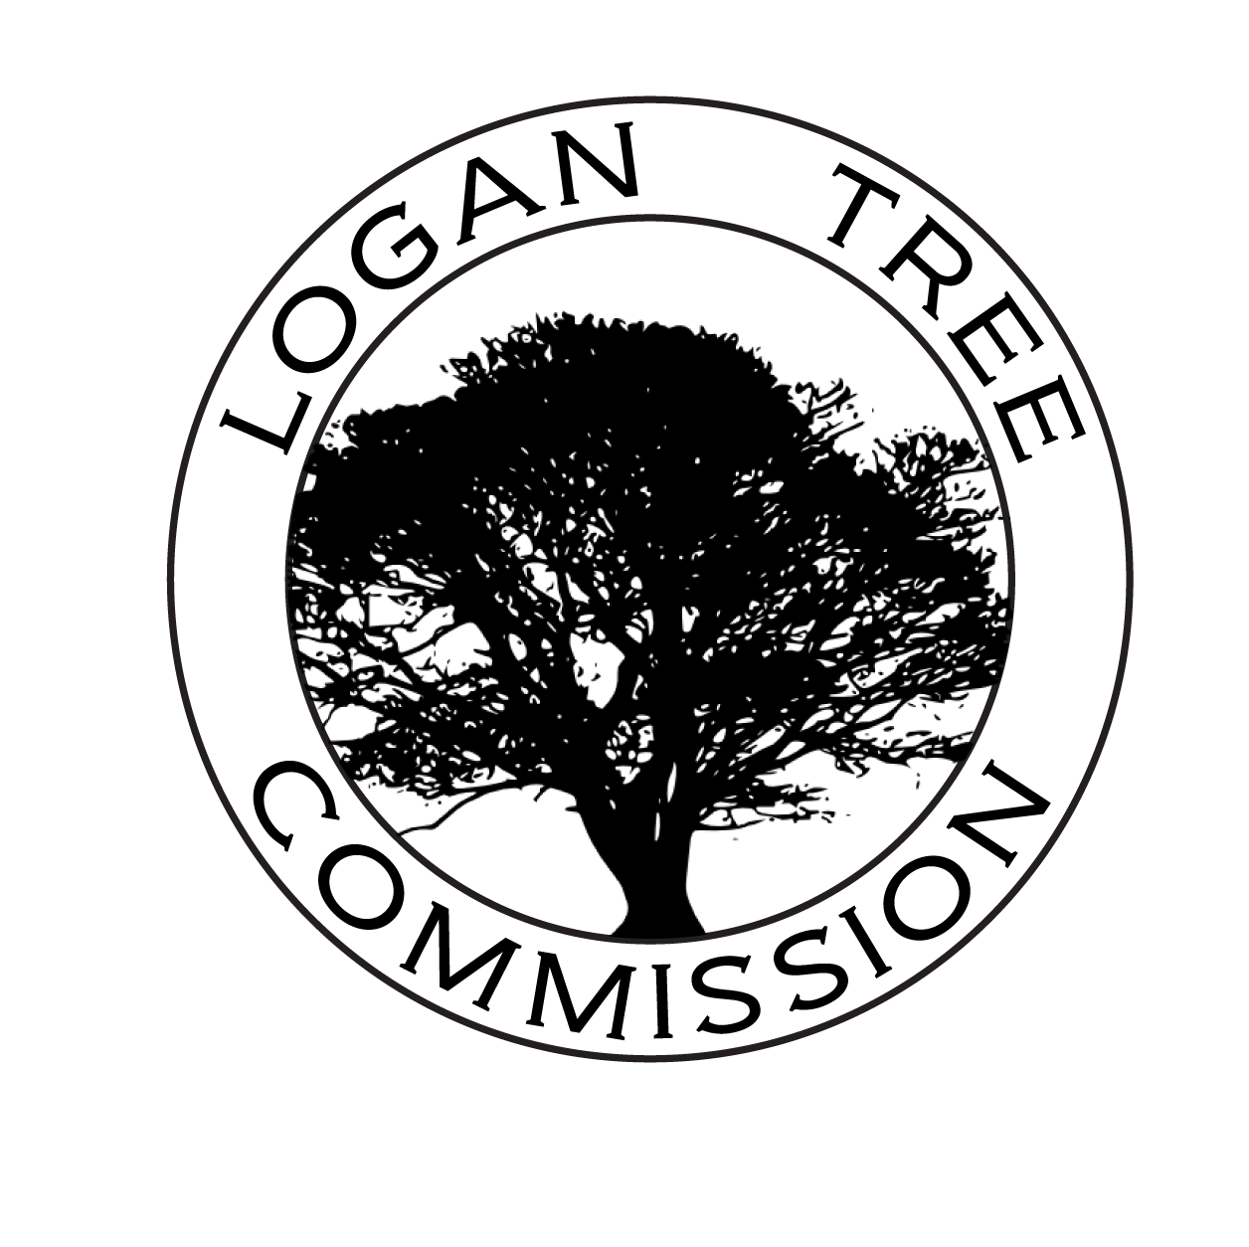

In 2001 the City of Logan embarked on a journey towards a safer, quieter, healthier community through the good stewardship of our street tree resources. Trees provide shade but they also add beauty, improve health, reduce air pollution, save energy, conserve water & soil, reduce noise pollution, increase economic stability and more. The appointed Tree Commission has worked diligently to establish ordinance, evaluation systems and administrative processes designed to help our citizens better understand the value of our urban forest. Through community involvement, grant research, education opportunities and volunteer commitment we have expanded the urban tree environment for residents and visitors. We are not only planting trees, but also planting urban heritage for future generations. This publication provides an overview of the City of Logan, Ohio’s Tree Ordinances and insight into appropriate plantings and maintenance issues relating to trees.   
  
Questions and comments may be directed to our City Service Director at 740-385-4060 or their office located at the corner of Main and Mulberry Street (St. Rt. 93 N).

**Suggested Plantings**

**LARGE TREES**

Very few areas are suitable for these plantings with the exception of an owner’s yard or a street lawn area of at least 7’ in width and no overhead utility lines.

* Mature height of 50’ plus
* Single trunk only

Hackberry- *Celtis occidentalis*

Ginkgo (MALE ONLY)- *Ginkgo biloba*

Thornless Honeylocust*­- Gleditsia triacanthos*

‘Skyline’

Kentucky Coffeetree- *Gymnocladus dioicus*

London Planetree- *Platanus x acerifolia*

Shumard Oak*- Quercus shumardii*

Bald Cypress*- Taxodium distichum*

Silver Linden*- Tilia tomentosa*

Elm - (‘Lacebark’ and ‘Pioneer’ are two Dutch Elm Disease resistant cultivars)- *Ulmus spp.*

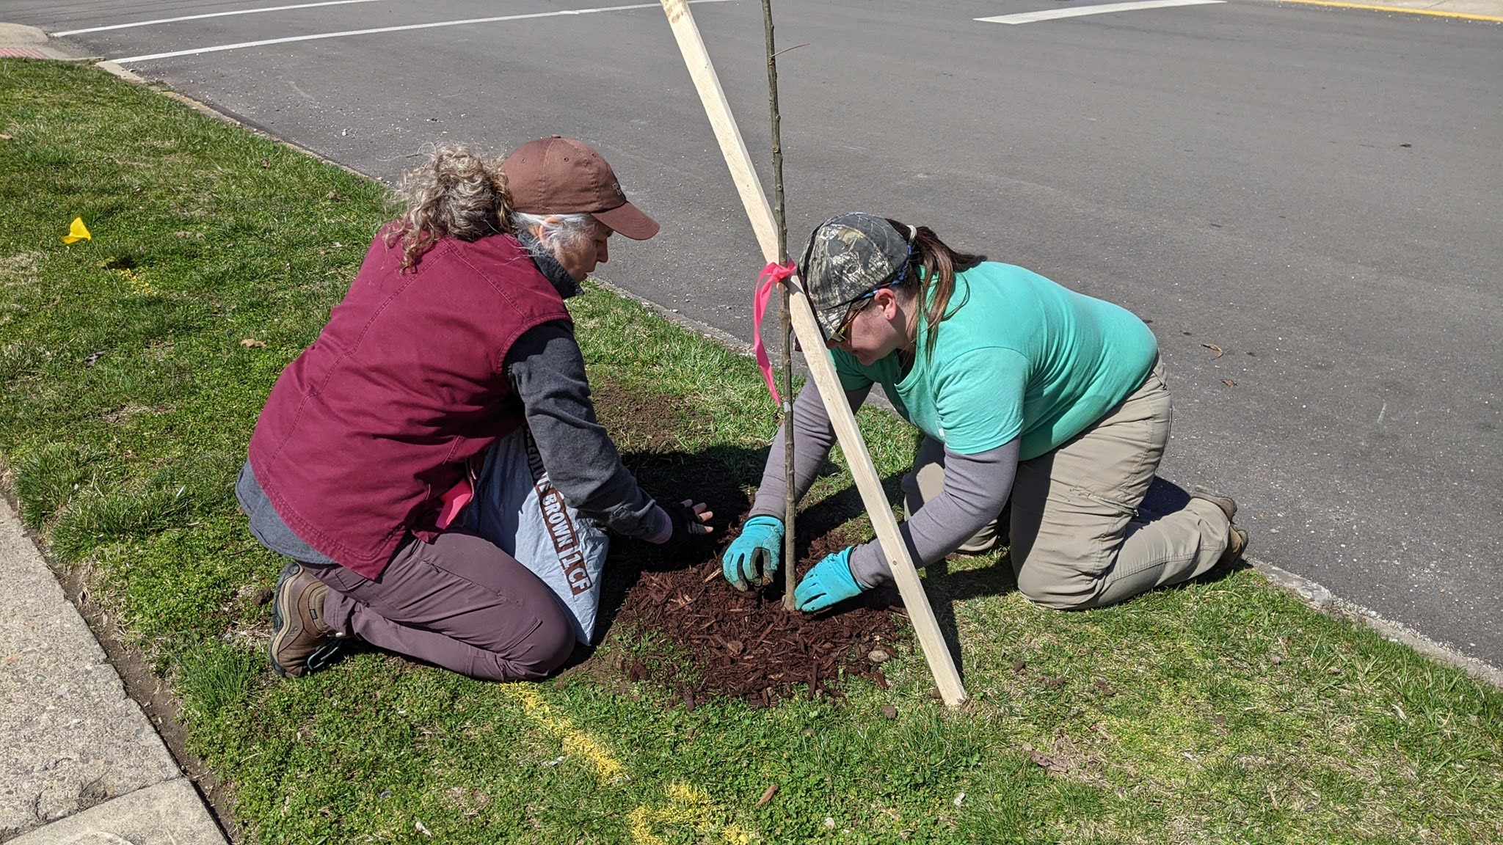

**Suggested Plantings**

**MEDIUM TREES**

* Mature height 30’-50’ (also good for within owner’s lawn)
* Single trunk only

River Birch*- Betula nigra*

Yellowwood*- Cladrastis kentukea*

Turkish Filbert*- Corylus colurna*

Sourwood- *Oxydendron arboreum* (great for early pollinators)

Eastern Hophornbeam/ Ironwood- *Ostrya virginiana*

Swamp White Oak*- Quercus bicolor*

Shingle Oak- *Quercus imbricaria*

Littleleaf Linden*- Tilia cordata* ‘Glenleven’, ‘Greenspire’

Japanese Pagoda*- Sophora japonica*

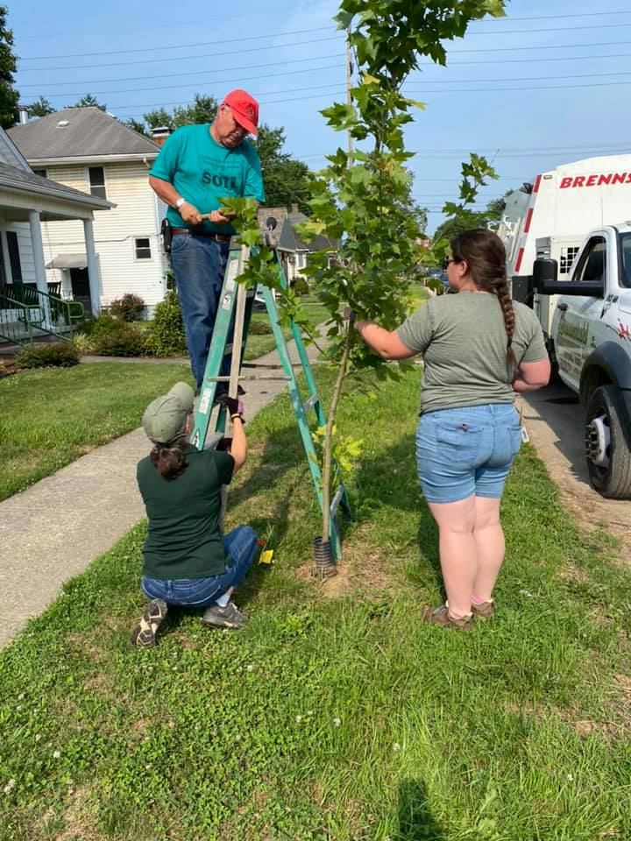

**Ordinance Overview**  
A sampling of the more important ordinances you may be interested in: (shortened for brochure purposes).

Ohio Revised Code Section 901.51 Injuring vines, bushes, trees or crops on land of another: No person, without privilege to do so, shall recklessly cut down, destroy, girdle, or otherwise injure a vine, bush, shrub, sapling, tree or crop standing or growing on the land of another or upon public land.

Section 93.07 Moving, Trimming, and Preserving of Trees and Shrubbery: Trees shall be trimmed by the owner, so they are structurally safe and do not obstruct pedestrian or vehicular travel. The City may prune or remove any tree that is unsafe and charge costs to the owner when it is in the vicinity of a street, sidewalk or public right-of-way. *In all cases, penalties may be assessed.

For a link to the Logan Tree Commission Tree Inquiry Form or for more information on certain ordinances, please refer to the Hocking SWCD Website at hockingswcd.com/forestry.

The Tree Commission seeks to inform and educate rather than enforce, so please call for assistance prior to taking any action to move, cut, remove, plant, or injure any tree within a public right-of-way. Thank you.